Lab 9 Report

Objectives

Lab 9 will use an ADC on the LaunchPad to provide a digital readout of the ambient temperature. The temperature range is 10 to 40°C. The measured temperature data will be displayed numerically as a fixed-point number on the LCD to two decimal places and the temperature over time will be graphed. The system must have a temperature measurement resolution of 0.1°C or better, with an average temperature accuracy should be 1°C or better. The frequency components of the signal are readings from 0 to 10 Hz.

Hardware Design

Below is a circuit schematic of the thermistor interface with the LaunchPad:

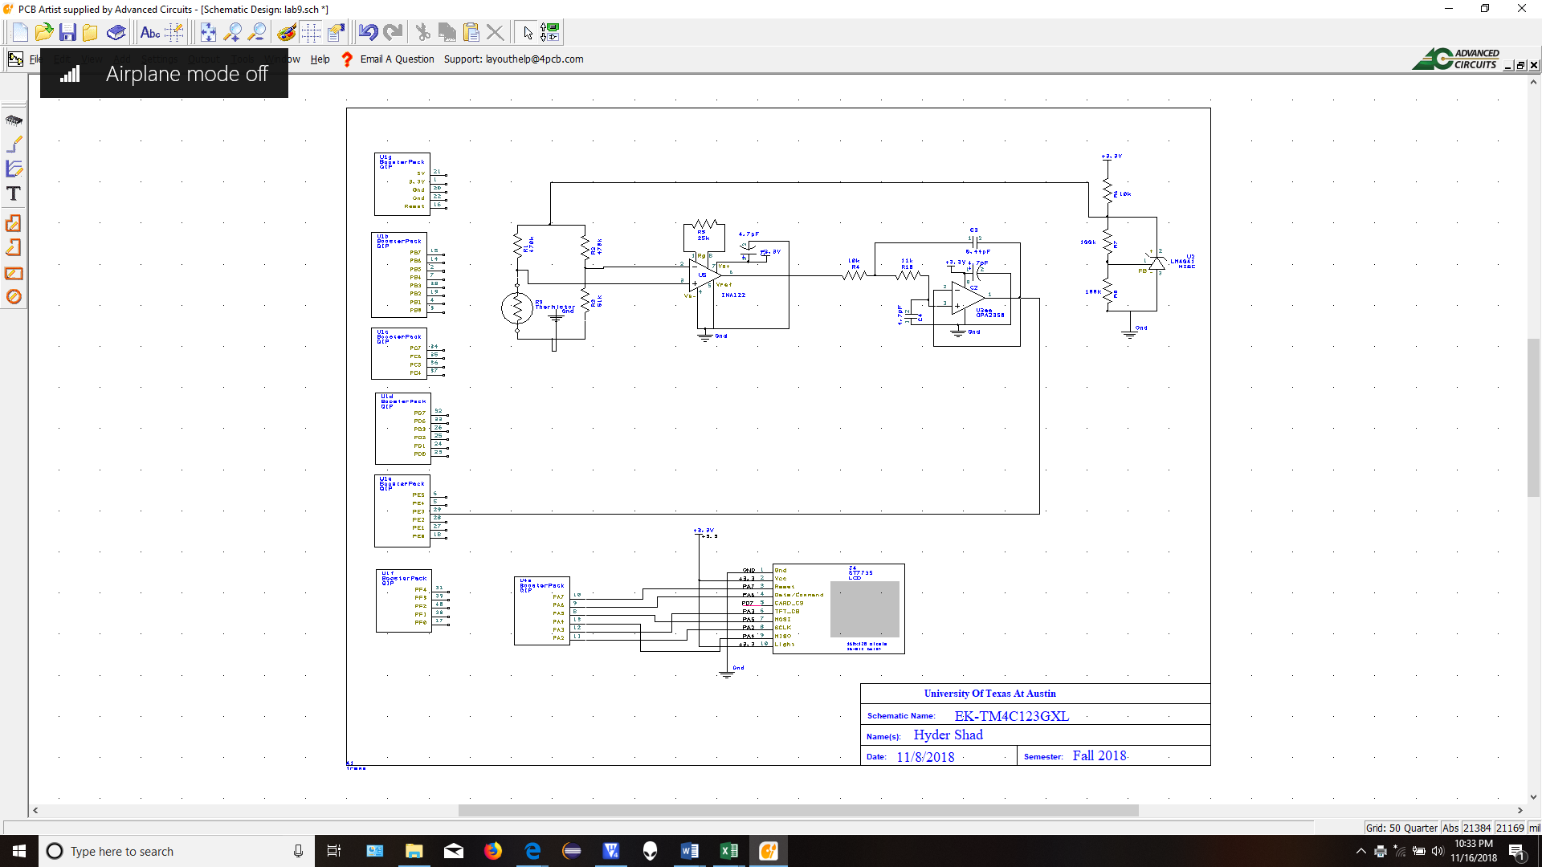

Calibration

The following values were obtained using the Therm12 xls spreadsheet to calibrate the ADC temperature conversion and circuit parameters:

First point: 101.kΩ at 15.09°C

Second point: 82.32kΩ at 36.04°C

R1 = R2 = 470kΩ

R3 = 65kΩ

V1 = 2.5V

V3 = 0.364V

β = 914.96885

Desired INA122 Rg = 13.98 kΩ

Gain = 19.664

Range: 1161 to 4091 on the ADC

Resolution: 0.007°C <= ∆T <= 0.008°C

The ADCdata, Tdata, and Rdata tables produced by the spreadsheet are included in the “calibration.h” file submitted along with this report.

Software Design

Please see the associated C and H files submitted along with this report for the Lab 9 software modules. The software design was based off the following data flow and call graph charts:



Data-flow graph



Call graph

Measurement Data

1. Static analog circuit test:

|  |  |  |  |  |
| --- | --- | --- | --- | --- |
| **R (kΩ)** |  | **Vs (V)** | **V2 (V)** | **V2 - V3 (V)** |
| 110 | Min | 2.719 | 0.987 | 0.623 |
| 110 | Max | 3.067 | 1.738 | 1.374 |
| 100 | Min | 2.016 | 1.102 | 0.738 |
| 100 | Max | 2.01 | 1.124 | 0.76 |
| 90 | Min | 1.215 | 0.945 | 0.581 |
| 90 | Max | 1.228 | 1.053 | 0.689 |
| 80 | Min | 0.269 | 0.902 | 0.538 |
| 80 | Max | 0.402 | 0.991 | 0.627 |
| open | Min | 3.18 | 2.16 | 1.796 |
| open | Max | 3.25 | 2.23 | 1.866 |
| short | Min | -0.09 | -0.08 | -0.444 |
| short | Max | 0.09 | 0.08 | -0.284 |

1. Dynamic Analog Test:

[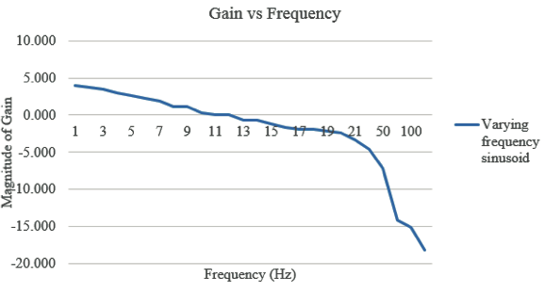](https://github.com/JohnStarich/ee445l/blob/master/Lab9/gainvfrequency.png)

1. Accuracy:

|  |  |  |
| --- | --- | --- |
| **True Temperature (°C)** | **Measured Temperature (°C)** | **Difference** |
| 31.5 | 33.5 | 2 |
| 31.5 | 33.9 | 2.4 |
| 31.5 | 33.6 | 2.1 |
| 31.5 | 33.6 | 2.1 |
| 31.5 | 33.4 | 1.9 |
| 31.5 | 33.3 | 1.8 |
| 31.5 | 33.2 | 1.7 |
| 31.5 | 33.7 | 2.2 |
| 31.5 | 33.7 | 2.2 |
| 31.5 | 34.0 | 2.5 |

The average difference across the measurements is 2.09 C

|  |  |
| --- | --- |
| **T** | **T²** |
| 28.68 | 822.5424 |
| 28.51 | 812.8201 |
| 28.46 | 809.9716 |
| 28.93 | 836.9449 |
| 28.45 | 809.4025 |
| 28.16 | 792.9856 |
| 28.19 | 794.6761 |
| 28.44 | 808.8336 |
| 28.65 | 820.8225 |
| 28.48 | 811.1104 |
| 28.46 | 816.2449 |
| Expectation – 28.57 |  |
| Var(T) | 0.00159 |
| Std Dev | 0.0289256 |

1. Reproducibility

Analysis

1. The Nyquist theorem is the minimum sampling frequency required to capture the original waveform through retain the waveform’s unique shape and characteristics. The theorem states that the sampling frequency must be at least twice that of the input frequency. The Nyquist theorem was applied in Lab 9 to ensure the ADC sampling rate was at least twice the input frequency of 10Hz to gather accurate data. This meant the ADC must sample at least 20 times a second.
2. Resolution is the smallest step of change in value in a system. Accuracy refers to the correctness of information captured. In this system, the resolution is smallest voltage change that the ADC on microcontroller can detect based on the number of bits and the input range of the particular ADC (0-3.3V with 12 bits). Accuracy is the variance between temperature information recorded by the ADC and the actual environmental temperature information measured by most other analog devices.
3. The precision and accuracy of the thermometer can be determined by finding out the standard deviation and variance amongst measurements when compared to the actual temperature readings.
4. ​The low pass filter is used to remove high frequency noise that may be present in the input from the circuit to the ADC. Potential sources of noise are the power line interference (at 60Hz), static, and fluctuations in the operating temperature or state of the ICs used.
5. The voltage versus temperature curve looks linear due to the circuit feedback and the mathematical equations used to relate the ADC samples to the actual temperature readings. The lookup tables provide for the corrections necessary to interpret the non-linear behavior as a linear relationship with temperature.
6. The linear method was avoided because the thermistor has a non-linear relationship between its resistance and temperature, and using a linear model would have caused error in the temperature calculations from the recorded ADC values. A large lookup table is better because there is less latency to find a recorded value from the table than there is to take an ADC sample and convert it. The lookup table in this case would not be large compared to the available memory and the fact that memory was not a constraint in this lab means it is feasible.